Introductions to Allocate Plus
First-in First-serve mode

Welcome to the Allocate Plus video for students. In this video you will be shown how to use Allocate Plus to create your timetable for on-campus subjects.
From the Allocate Plus webpage you can access the system, view Frequently Asked Questions and find contact details for help.
Allocate Plus has two modes through which students can access the system. See the important dates on the University Website for times when these modes are active.
The modes are Preference mode and First-in First-serve mode. Preference mode is when students are able to select their preferred activities for each subject. The system closes after preference mode is complete and allocates students to activities based on their preferences selected during this mode. When the system re-opens in First-in First-serve mode, students can allocate themselves to activities that the system was unable to automatically allocate. The focus of this video is how students can allocate themselves to activities in First-in First-serve mode. The earlier you access the system during this mode, the greater your chances are of securing your desired timetable.
You can login to Allocate Plus by clicking Student Login and entering your usual university username and password.

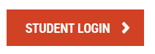
Once you have logged in, you will see the homepage and your enrolment details on the left-hand side.
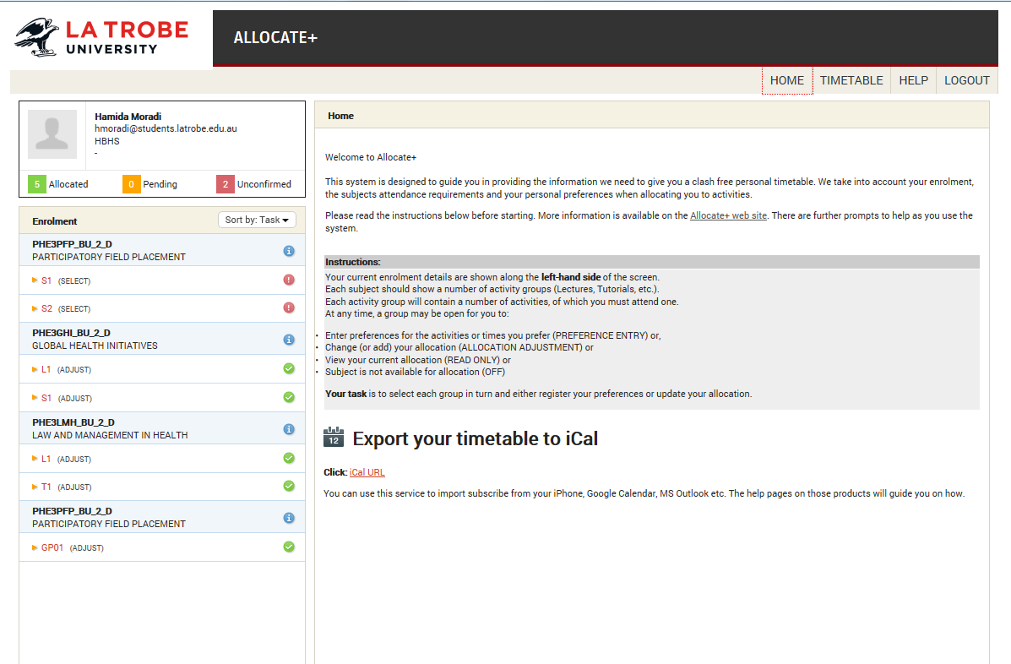
You can view your timetable by clicking here.
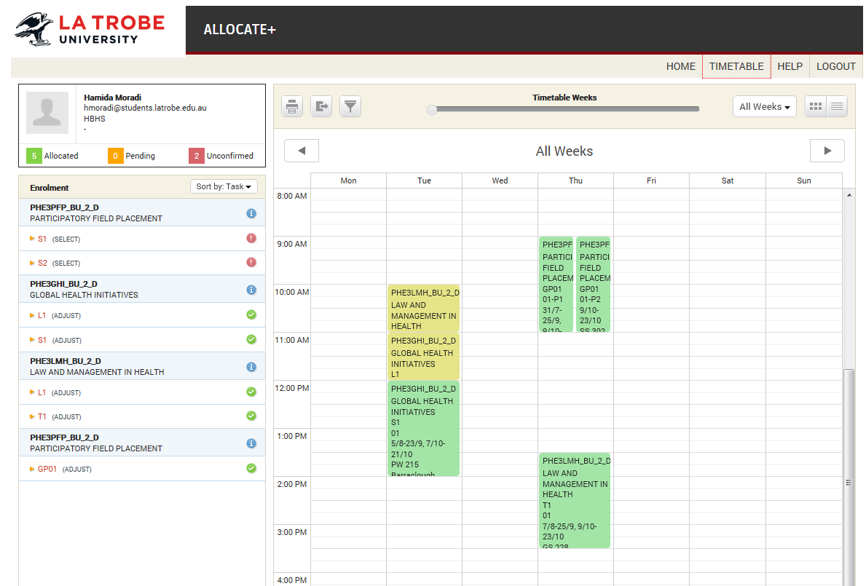
Your full timetable is only visible when all of your groups have been allocated, and are marked with a green tick. Your allocated classes display per week and you can click through the weeks.

You can view the subject description by clicking the blue i icon. Each subject with on-campus activities will have one or more groups displayed. The group code indicates the type of activities in that group, for example L for lecture, T for Tutorial (A full list can be found in the student reference guide on the University website)
Beside each group is a green tick (meaning Allocated), orange dots (meaning pending) or a red exclamation point (which means Unconfirmed).
Allocated groups, those with a green tick, do not require any action to be taken, as these have already been allocated to you.
Pending & Unconfirmed groups require you to perform an action.
If you have selected a preference in a group that clashes with a preference in a different group, the system randomly selects one of your choices and allocates you to that choice. The others will remain unconfirmed with a red icon. Students can contact the Student Hub for advice on activities that are clashing.
Click on a group that is marked Allocated. The activity options for this group are displayed on the right, and each activity relates to a specific class venue and time. Only one activity option needs to be selected in each group.
The activity option is set to Allocated, which means you have already been allocated to an activity in this group.

